SQL Constraints

🌟 Definition
# Source: AI Source: Provided by: [Data Path: Persons Table -> ID Column: 1, Name_En Column: Motasem Essam] -> From: [ChatGPT] on [6/11/2026]
SQL Constraints are rules applied to table columns that control what data can be stored in a database.
Constraints help maintain:
- Data accuracy
- Data consistency
- Data integrity
- Data reliability
They prevent invalid or unwanted data from being inserted into tables.

🎯 Purpose
# Source: AI Source: Provided by: [Data Path: Persons Table -> ID Column: 1, Name_En Column: Motasem Essam] -> From: [ChatGPT] on [6/11/2026]
SQL Constraints are used to:
- Ensure unique values
- Prevent missing data
- Enforce relationships between tables
- Validate data rules
- Set default values

🧠 Simple Example
# Source: AI Source: Provided by: [Data Path: Persons Table -> ID Column: 1, Name_En Column: Motasem Essam] -> From: [ChatGPT] on [6/11/2026]
Suppose every customer must have a unique ID.
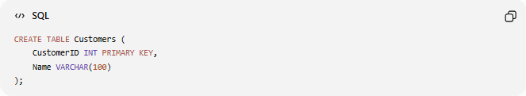
CREATE TABLE Customers (
CustomerID INT PRIMARY KEY,
Name VARCHAR(100)
);
The database will not allow two customers with the same CustomerID.

📚 Main SQL Constraints
# Source: AI Source: Provided by: [Data Path: Persons Table -> ID Column: 1, Name_En Column: Motasem Essam] -> From: [ChatGPT] on [6/11/2026]
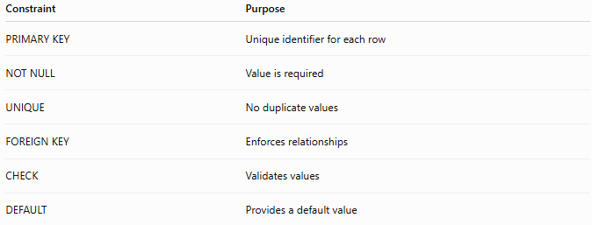
Constraint | Purpose
PRIMARY KEY | Unique identifier for each row
NOT NULL | Value is required
UNIQUE | No duplicate values
FOREIGN KEY | Enforces relationships
CHECK | Validates values
DEFAULT | Provides a default value

1️⃣ PRIMARY KEY Constraint
# Source: AI Source: Provided by: [Data Path: Persons Table -> ID Column: 1, Name_En Column: Motasem Essam] -> From: [ChatGPT] on [6/11/2026]
Purpose
Uniquely identifies each record in a table.
Example
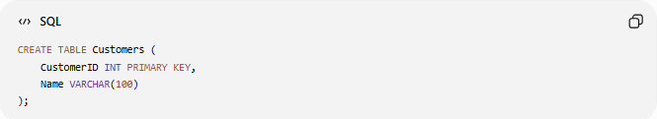
CREATE TABLE Customers (
CustomerID INT PRIMARY KEY,
Name VARCHAR(100)
);

Valid Data
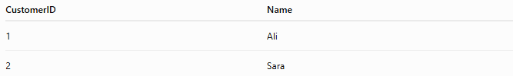
CustomerID | Name
1 | Ali
2 | Sara

Invalid Data
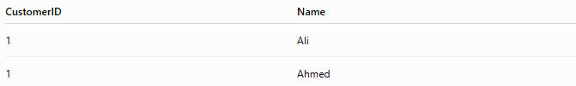
CustomerID | Name
1 | Ali
1 | Ahmed
Duplicate primary keys are not allowed.

Characteristics
A Primary Key:
- Must be unique
- Cannot be NULL
- One primary key per table

2️⃣ NOT NULL Constraint
# Source: AI Source: Provided by: [Data Path: Persons Table -> ID Column: 1, Name_En Column: Motasem Essam] -> From: [ChatGPT] on [6/11/2026]
Purpose
Requires a column to contain a value.
Example
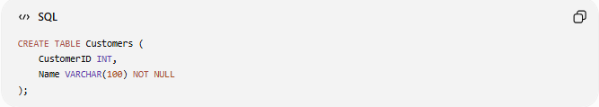
CREATE TABLE Customers (
CustomerID INT,
Name VARCHAR(100) NOT NULL
);

Valid
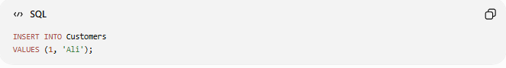
INSERT INTO Customers
VALUES (1, 'Ali');

Invalid
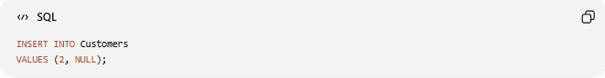
INSERT INTO Customers
VALUES (2, NULL);
Error because Name cannot be NULL.

3️⃣ UNIQUE Constraint
# Source: AI Source: Provided by: [Data Path: Persons Table -> ID Column: 1, Name_En Column: Motasem Essam] -> From: [ChatGPT] on [6/11/2026]
Purpose
Prevents duplicate values.
Example
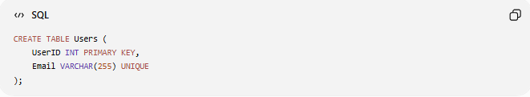
CREATE TABLE Users (
UserID INT PRIMARY KEY,
Email VARCHAR(255) UNIQUE
);

Valid
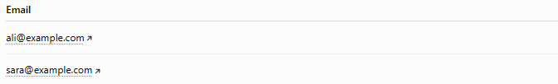
Email
ali@example.com
sara@example.com

Invalid
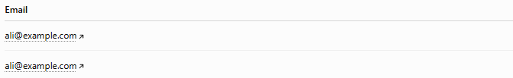
Email
ali@example.com
ali@example.com
Duplicate emails are not allowed.

4️⃣ FOREIGN KEY Constraint
# Source: AI Source: Provided by: [Data Path: Persons Table -> ID Column: 1, Name_En Column: Motasem Essam] -> From: [ChatGPT] on [6/11/2026]
Purpose
Creates a relationship between tables.
Customers Table
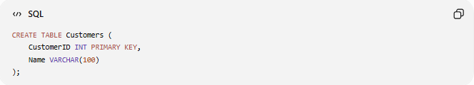
CREATE TABLE Customers (
CustomerID INT PRIMARY KEY,
Name VARCHAR(100)
);

Orders Table
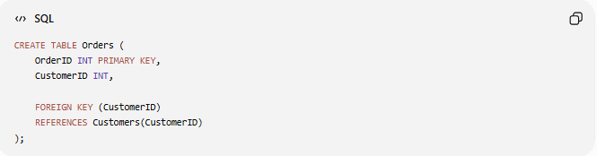
CREATE TABLE Orders (
OrderID INT PRIMARY KEY,
CustomerID INT,

FOREIGN KEY (CustomerID)
REFERENCES Customers(CustomerID)
);

Relationship
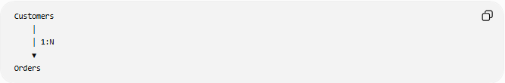
Customers
│
│ 1:N
▼
Orders

Benefit
Every order must belong to an existing customer.

5️⃣ CHECK Constraint
# Source: AI Source: Provided by: [Data Path: Persons Table -> ID Column: 1, Name_En Column: Motasem Essam] -> From: [ChatGPT] on [6/11/2026]
Purpose
Validates data using a condition.
Example
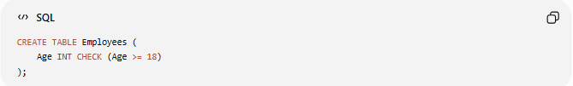
CREATE TABLE Employees (
Age INT CHECK (Age >= 18)
);

Valid
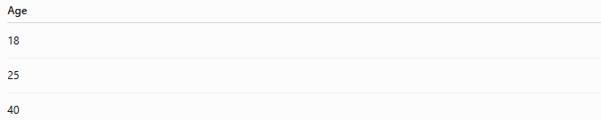
Age
18
25
40

Invalid
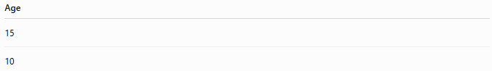
Age
15
10
Rejected because the condition is not met.

6️⃣ DEFAULT Constraint
# Source: AI Source: Provided by: [Data Path: Persons Table -> ID Column: 1, Name_En Column: Motasem Essam] -> From: [ChatGPT] on [6/11/2026]
Purpose
Automatically assigns a value when none is provided.
Example
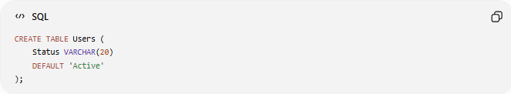
CREATE TABLE Users (
Status VARCHAR(20)
DEFAULT 'Active'
);

Insert
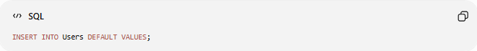
INSERT INTO Users DEFAULT VALUES;

Result
Status
Active
The database automatically supplies the default value.

📊 Side-by-Side Comparison
# Source: AI Source: Provided by: [Data Path: Persons Table -> ID Column: 1, Name_En Column: Motasem Essam] -> From: [ChatGPT] on [6/11/2026]
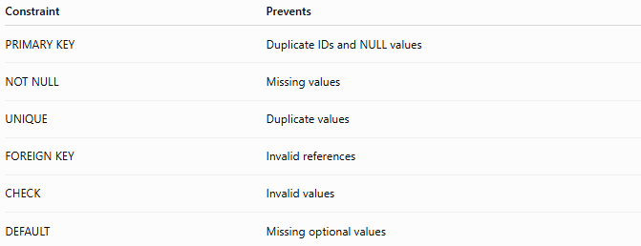
Constraint | Prevents
PRIMARY KEY | Duplicate IDs and NULL values
NOT NULL | Missing values
UNIQUE | Duplicate values
FOREIGN KEY | Invalid references
CHECK | Invalid values
DEFAULT | Missing optional values

🛠️ Complete Example
# Source: AI Source: Provided by: [Data Path: Persons Table -> ID Column: 1, Name_En Column: Motasem Essam] -> From: [ChatGPT] on [6/11/2026]
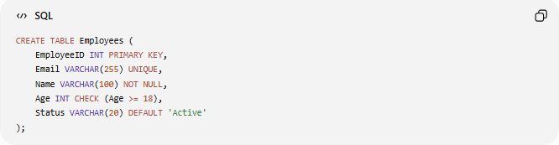
CREATE TABLE Employees (
EmployeeID INT PRIMARY KEY,
Email VARCHAR(255) UNIQUE,
Name VARCHAR(100) NOT NULL,
Age INT CHECK (Age >= 18),
Status VARCHAR(20) DEFAULT 'Active'
);

Constraints Used
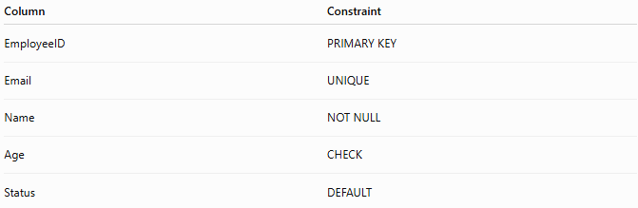
Column | Constraint
EmployeeID | PRIMARY KEY
Email | UNIQUE
Name | NOT NULL
Age | CHECK
Status | DEFAULT

🌍 Online Store Example
# Source: AI Source: Provided by: [Data Path: Persons Table -> ID Column: 1, Name_En Column: Motasem Essam] -> From: [ChatGPT] on [6/11/2026]
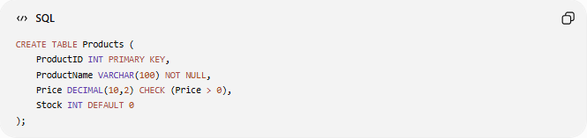
CREATE TABLE Products (
ProductID INT PRIMARY KEY,
ProductName VARCHAR(100) NOT NULL,
Price DECIMAL(10,2) CHECK (Price > 0),
Stock INT DEFAULT 0
);

Rules
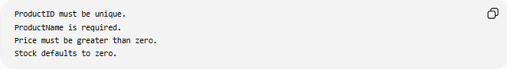
ProductID must be unique.
ProductName is required.
Price must be greater than zero.
Stock defaults to zero.

⚖️ Side-by-Side Comparison
# Source: AI Source: Provided by: [Data Path: Persons Table -> ID Column: 1, Name_En Column: Motasem Essam] -> From: [ChatGPT] on [6/11/2026]
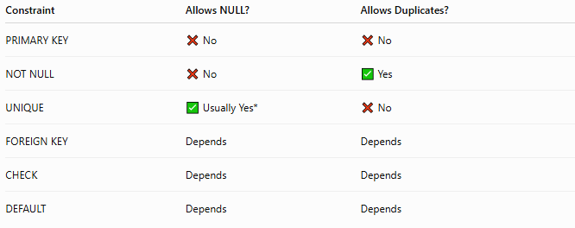
Constraint | Allows NULL? | Allows Duplicates?
PRIMARY KEY | ❌ No | ❌ No
NOT NULL | ❌ No | ✅ Yes
UNIQUE | ✅ Usually Yes* | ❌ No
FOREIGN KEY | Depends | Depends
CHECK | Depends | Depends
DEFAULT | Depends | Depends
* Database behavior regarding NULLs in UNIQUE columns may vary.

🔢 Constraint Hierarchy
# Source: AI Source: Provided by: [Data Path: Persons Table -> ID Column: 1, Name_En Column: Motasem Essam] -> From: [ChatGPT] on [6/11/2026]
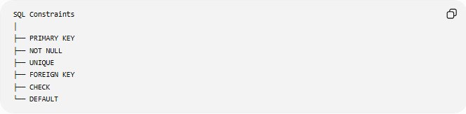
SQL Constraints
│
├── PRIMARY KEY
├── NOT NULL
├── UNIQUE
├── FOREIGN KEY
├── CHECK
└── DEFAULT

🧠 Simple Analogy
# Source: AI Source: Provided by: [Data Path: Persons Table -> ID Column: 1, Name_En Column: Motasem Essam] -> From: [ChatGPT] on [6/11/2026]
Think of a university registration system.
Rules:
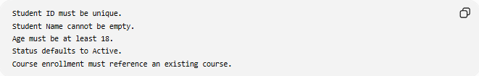
Student ID must be unique.
Student Name cannot be empty.
Age must be at least 18.
Status defaults to Active.
Course enrollment must reference an existing course.
These rules act like SQL Constraints.
They ensure only valid information enters the system.

🧭 Summary
# Source: AI Source: Provided by: [Data Path: Persons Table -> ID Column: 1, Name_En Column: Motasem Essam] -> From: [ChatGPT] on [6/11/2026]
SQL Constraints are rules applied to database tables to ensure data integrity and consistency. The most common constraints are PRIMARY KEY, NOT NULL, UNIQUE, FOREIGN KEY, CHECK, and DEFAULT. They help prevent duplicate data, missing values, invalid references, and incorrect entries while enforcing business rules within a database.

